TicketTrack v.1.5.1.27
User Guide

- Network Installation Instructions
- Adding New Tickets (Add button)
- Modifying Existing Tickets (Edit button)
- Archived Tickets (View Archive button)
- Tips

Chapter 1: Network Installation Instructions

- Navigate to R:\Alticor\It\ETS\Service Desk\TicketTrack\ directory.
- Run the setup.exe file in the directory.
- Follow the on screen prompts. You may be prompted to download and install the .Net 4 Framework and the SQL connectivity suite. If this is the case go ahead and accept the license agreements and install.
- A reboot of your computer may be required.
- Now the TicketTrack (Example 1.1) software is installed on your computer. Double-click the icon on your desktop (Example 1.2) or in your start menu (under Service Desk Tools).
Example 1.1:
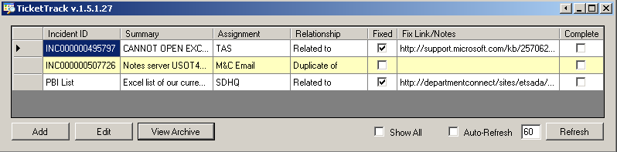
Example 1.2:
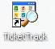

Chapter 2: Adding New Tickets (Add button)

- Click the Add button at the bottom left hand corner of the TicketTrack window.
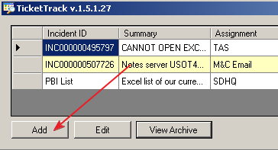
- You will be prompted with the “Add Watch Ticket” screen.
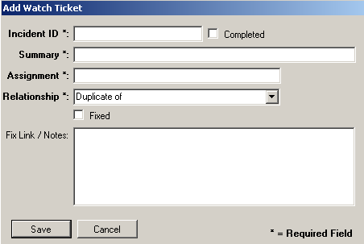
- You must fill out the Incident ID, Summary, Assignment, and choose a Relationship before saving the new Watch Ticket.
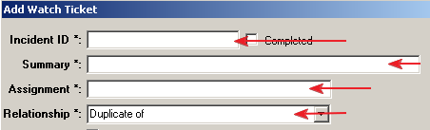

- The following is a list of the allowed relationships based on our Remedy relationship types.
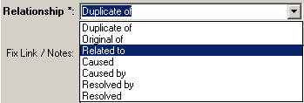
- Once the required information is filled out click on the Save button.
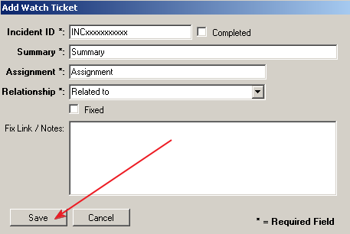
- Now that the Watch Ticket is saved, you will see it in the Ticket Queue. Only tickets that are not marked Complete will show in the default view of the Ticket Queue.
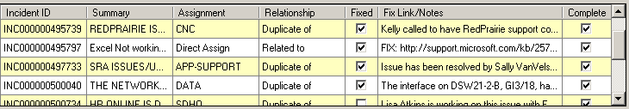

Chapter 3: Modifying Existing Tickets (Edit button)
- To edit a Watch Ticket you can do one of two things:
  - Select the Incident you would like to edit and then click the Edit button in the lower right hand corner of the TicketTrack window.
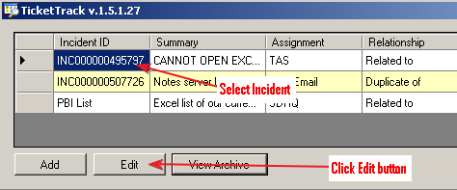
  - Select and double-click the Incident in the Ticket Queue.
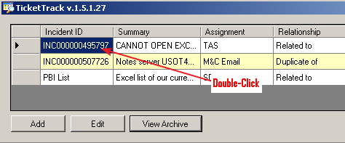

- The Edit Watch Ticket screen is the same as the Add Watch Ticket only it will show the information for your selected Incident. In this view you cannot edit the Incident ID. You may edit any other information listed. Once you’ve made your changes to the Watch Ticket click the Save button.
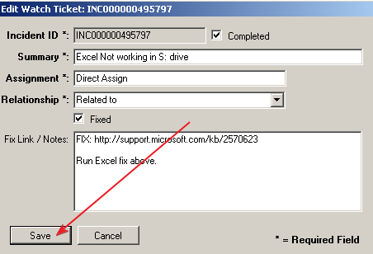
- Now the incident will be updated in the Ticket Queue.

Chapter 6: Archived Tickets (View Archive button)

- To open the archive file click the View Archive button next to Edit.
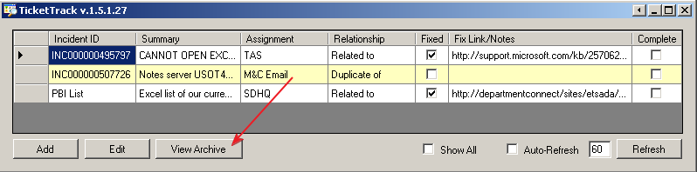

- This opens the TicketTrack – Archive window.
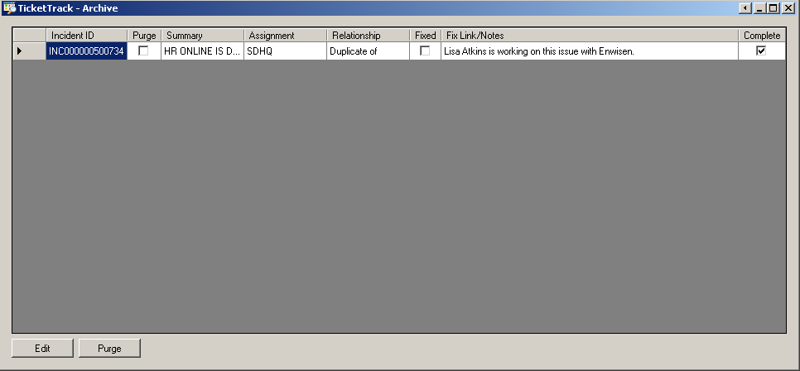

- From this view you can view all past tickets that have not been purged. To purge a ticket or tickets double-click or select the Incident ID and click Edit.
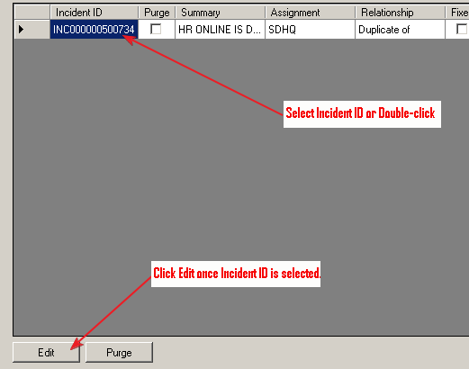
- You will be prompted with the “Edit Archive Ticket” screen.
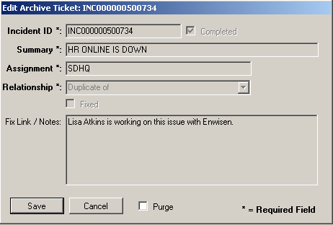

- To set the ticket to be purged, check the Purge box.
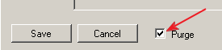
- Now click the Save button.
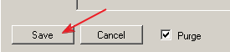
- To purge the selected tickets from the Archive click the Purge button at the bottom of the Archive Queue.
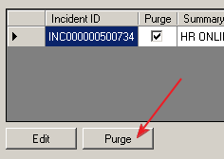
- You will be prompted to verify that you really want to purge the Archive. By clicking Yes you will confirm and purge any ticket that has the Purge box checked.
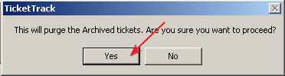

Chapter 5: Tips

- Fix Link / Notes hotspot for Ticket Queue.
  - If there is a hotfix or a link that needs to be shared for a Watch Ticket you may post it in the Fix Link/Notes section of the ticket.
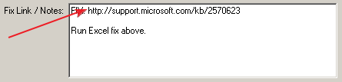
  - The hyperlink can’t contain spaces. If your hyperlink contains spaces, they must be replaced with “%20” HTML code. For example: http://departmentconnect/sites/etsada/sdhq/Shared%20Documents/2011-07-26%20Open%20PBI%E2%80%99s%20of%20Interest.xls
  - Also make sure the “Fixed” checkbox is Checked. Otherwise this option is not available.
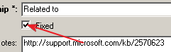
  - To open the Fix Link double-click the Fix Link/Notes field in the Ticket Queue
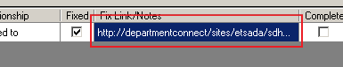

  - This will open the link in your default browser.
- Show All option
  - In the lower right hand corner of the Ticket Queue you’ll see a Show All option.
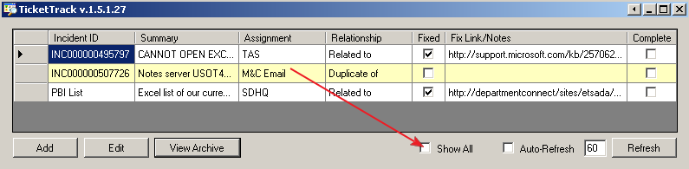

  - By default this option is unchecked. Which means only the tickets that are not completed will be shown.

  - If you are wanting to look at the past Watch Tickets that are completed you can check the Show All option.
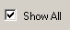
  - This will display everything in the Ticket Queue, completed and non-completed items automatically.
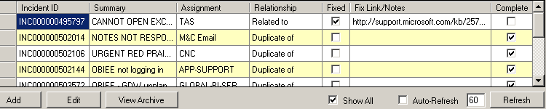

  - To go back to the default views simply uncheck the Show All option.
- Auto-Refresh options
  - By default the Ticket Queue will only refresh when the Refresh button is clicked. Also anytime a Watch Ticket is added or changed (edited) the Ticket Queue will refresh.
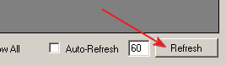
  - If you would like to set an Auto-Refresh check the Auto-Refresh option and then set the refresh rate.
